**Pyber Analysis**

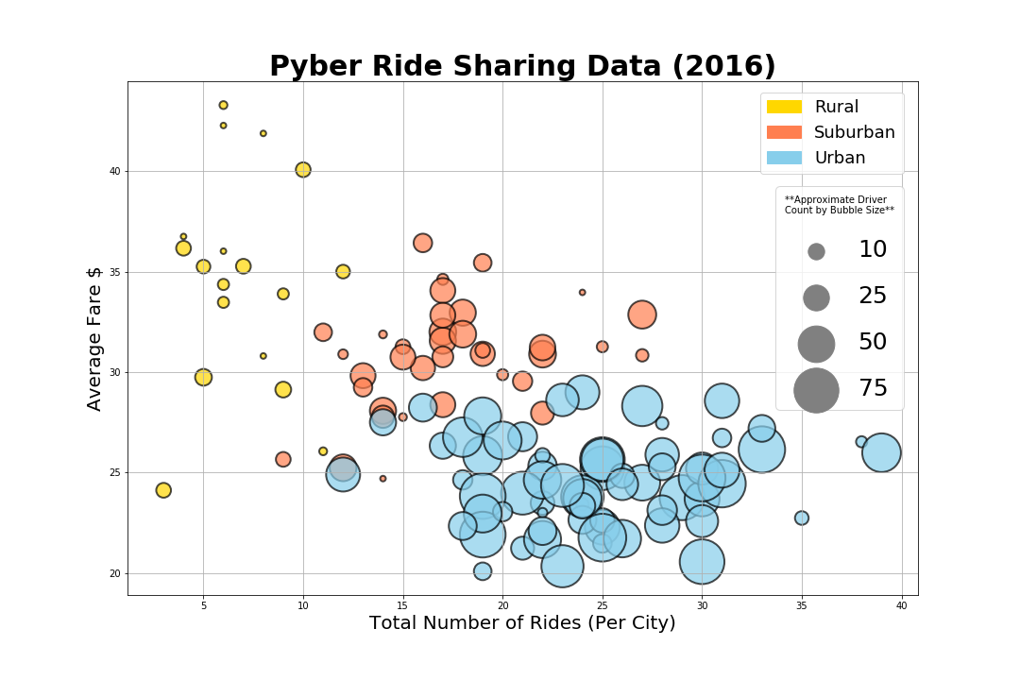

* Per the above bubble chart, we can see clear correlations between the number of drivers, number of rides, and type of cites.
* In the cities that have the lowest demand for rides, there are less drivers on average (Rural). In the cities that have the highest demand for rides, there are more drivers on average (Urban). The suburban cities fall somewhere in the middle of the two extremes of the data set with a moderate number of rides and drivers in comparison.
* To add to this observation, this disparity creates a supply/ demand dynamic. The cities with the lowest supply of drivers, on average, appear to have a premium on their average fair prices.
* Note, this higher average fare price could also be due to the fact that rides in rural settings probably cover longer distances since the infrastructure is more spread out and potential destinations can be few and far between.

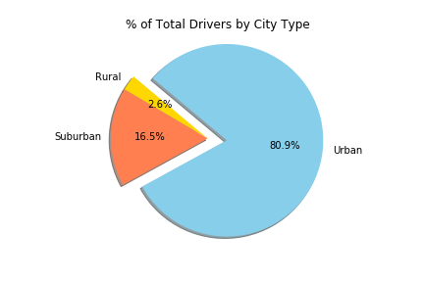

* The biggest piece of the pie as far as percentage of total drivers goes to urban cities at 80.9%.
* Rural cities have the lowest percentage of drivers (2.6%) and suburban cities have the median percentage of drivers (16.5%).

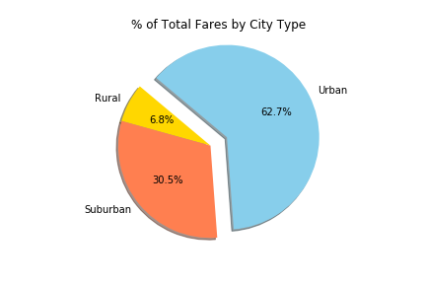

* Even through urban fares are cheaper on average, they share the greatest percent of the fares being charged overall at 62.7%. This is attributable to the fact that the volume of rides is so high in these types of cities. Even though they are the lowest priced due to abundant competition, they have a higher overall sum when volume is taken into account.
* Even though rural rides are the most expensive, they only account for 6.8% of the overall fares due to the low volume.
* Suburban Rides account for 30.5% of the overall fares.

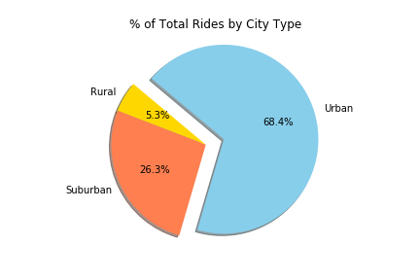

* As expected, urban cities have the highest share of rides (68.4%). A contributing factor to this is also the fact that urban cities are more densely populated, thus they are going to naturally have higher demand.
* Rural cities are likely the most sparsely populated city types and they only account for 5.3% of the total rides.
* Suburban cities account for 26.3% of the overall rides.